GRADE 7 ACCELERATED · UNIT 2 · LESSON 4
Approximating Irrational Numbers
Worksheet 7A.02.04 ANSWER KEY

1. Find the value of each. If there is no real value, write “no real value.”
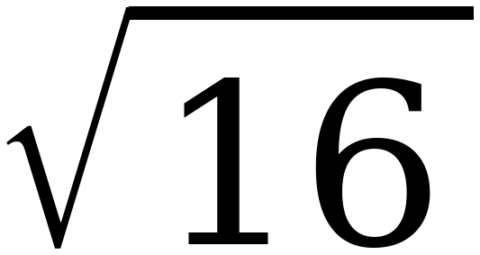  4 | 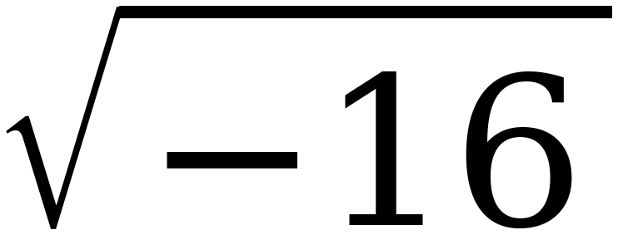  no real value | 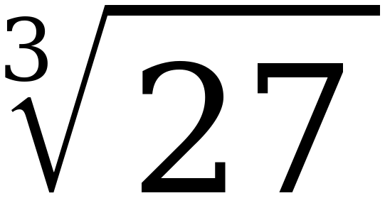  3 | 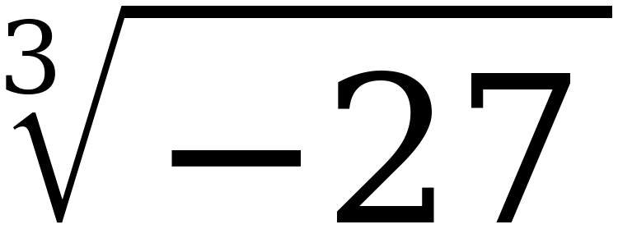  −3

Only the square root of a negative is refused. Three negative factors give a negative product, so a cube root of a negative is a real number.
2. Which of the four in question 1 had no real value? Explain when that happens.
√−16 has no real value.
A square root of a negative number is never real, because any real number times itself is positive or zero.
The point needs the reason, not just the letter. Cube roots are never refused.
3. Select ALL of the numbers below that are irrational.
☐ | 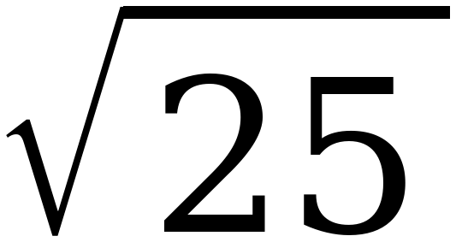 | ☒ | 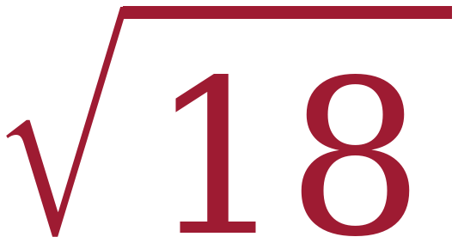
☐ |  | ☒ | 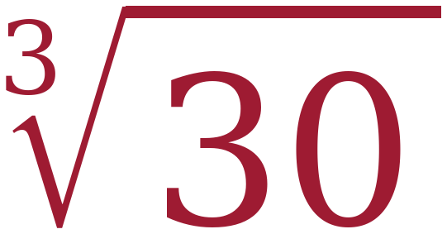
☒ | π | ☐ | 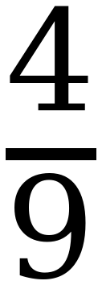

Three of the six. √25 = 5 and ∛27 = 3 are whole numbers, and 4/9 is already a ratio of two integers. 18 is not a perfect square and 30 is not a perfect cube, so those two roots never terminate and never repeat. π is the one students always get right.
Questions 4 and 5: name the perfect squares or cubes first, then the root.
4. 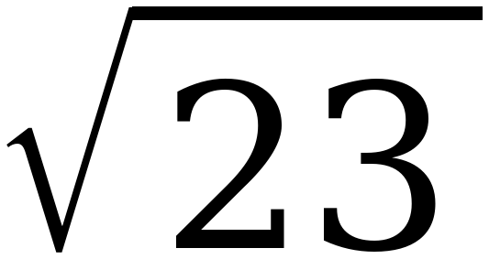
a. 23 lies between the perfect squares ______ and ______.
16 and 25
b. So the root lies between the integers ______ and ______.
4 and 5
c. The root is closer to ______.
5
23 − 16 = 7 and 25 − 23 = 2, so 23 sits nearer 25. That is why √23 is closer to 5.

5. 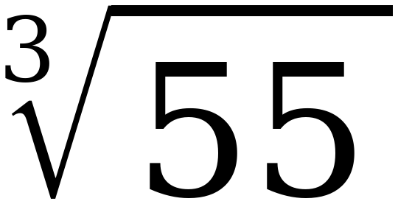
a. 55 lies between the perfect cubes ______ and ______.
27 and 64
b. So the root lies between the integers ______ and ______.
3 and 4
c. The root is closer to ______.
4
55 − 27 = 28 and 64 − 55 = 9, so 55 sits nearer 64.

6. Approximate 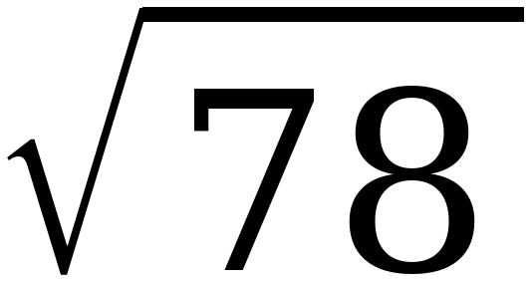 to the nearest tenth. Fill in the table, then decide.
Try | Result | How far from 78
8.8 × itself | 77.44 | 0.56
8.9 × itself | 79.21 | 1.21

To the nearest tenth, the value is 8.8
8.8 misses by 0.56 and 8.9 misses by 1.21, so 8.8 is the better tenth. Students who stop after finding 8 and 9 have done half the work.
7. Approximate 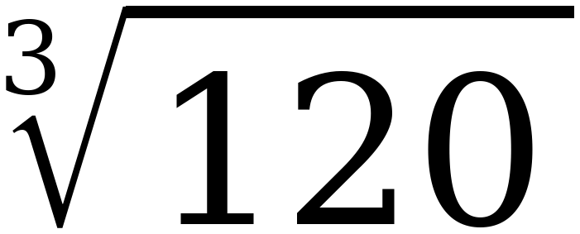 to the nearest tenth. Fill in the table, then decide.
Try | Result | How far from 120
4.9 cubed | 117.649 | 2.351
5 cubed | 125 | 5

To the nearest tenth, the value is 4.9
4.9 misses by 2.351 and 5.0 misses by 5, so 4.9 wins. Cubing three decimals by hand is slow — let them use the calculator here and say so.
8. Use ≈ 8.83 to approximate each expression to the nearest tenth.

Expression | Approximate Value
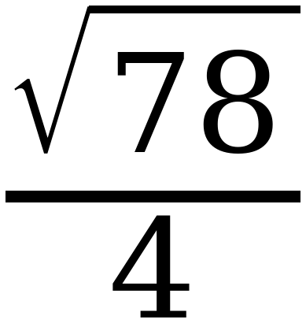 | 2.2
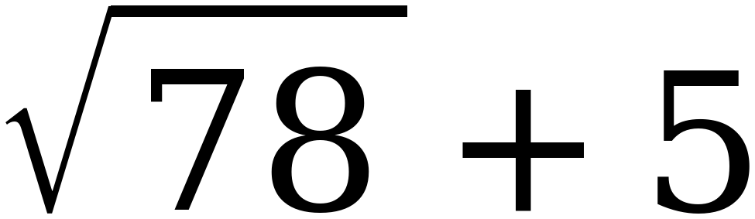 | 13.8
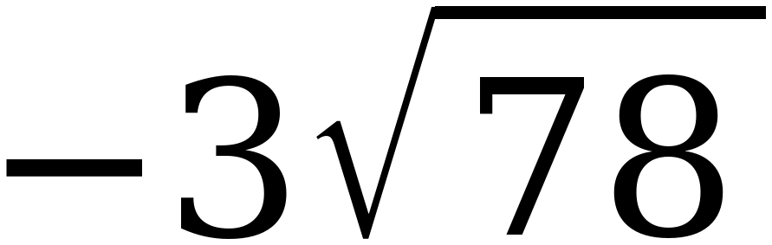 | −26.5

The third row is why the sheet says 8.83 rather than 8.8. Multiplying the rounded 8.8 by −3 gives −26.4, which is off by a tenth. When you are going to multiply, carry an extra decimal place first.
9. Approximate the value of each expression to the nearest tenth.

 | Expression | Approximate Value
A |  | 4.9
B | 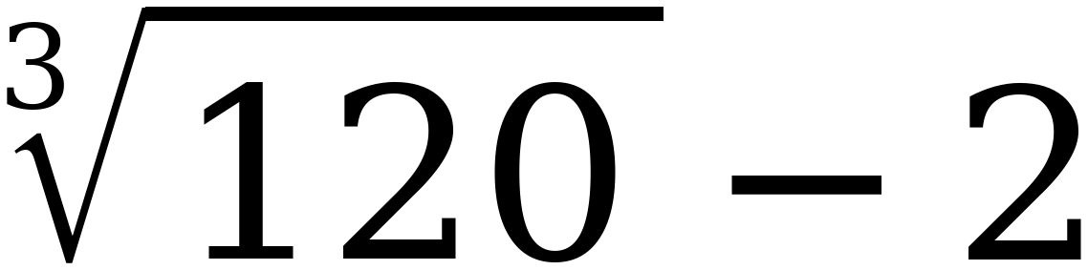 | 2.9
C | 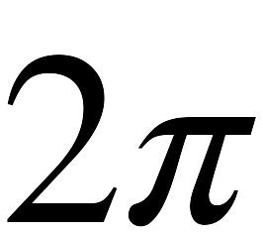 | 6.3
D | 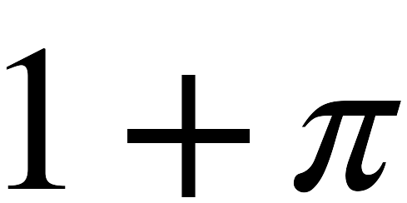 | 4.1

10. Plot and label A, B, C and D on the number line.
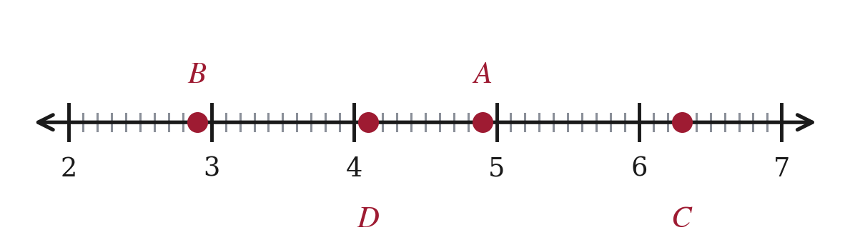
B = 2.9, D = 4.1, A = 4.9, C = 6.3. The tick points are tenths, so every one of these lands exactly on a mark.
11. Priya says that because 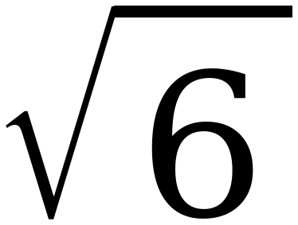 ≈ 2.4, the value of 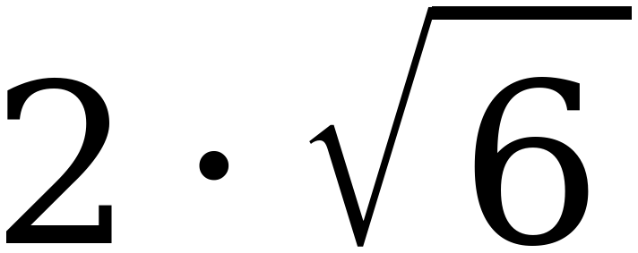 is 4.8. Her calculator says 4.9. Who is right, and what went wrong?
The calculator is right. 2√6 = 4.898…, which is 4.9 to the nearest tenth.
Priya rounded first and then multiplied. Rounding 2.449 down to 2.4 lost 0.049, and doubling it lost 0.098 — almost a whole tenth.
Using √6 ≈ 2.45 gives 2 × 2.45 = 4.90, which rounds correctly.
This is the same idea as question 8 and it is the one genuinely new skill in this lesson. Adding or subtracting is safe; multiplying and dividing are not. Round last, or carry an extra place.

